Want to go to Walt Disney World Resorts?
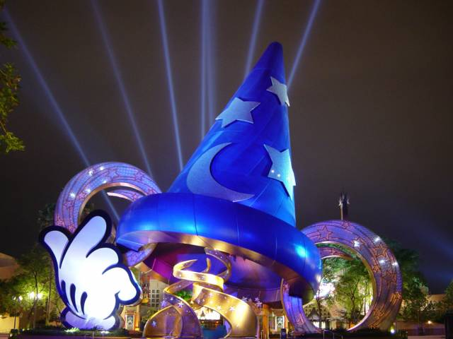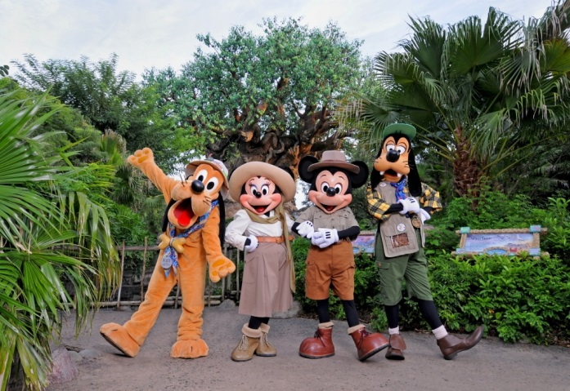

HERE’S HOW -
See one of our Arcadia Guild members
to buy chances to win:

~ (4) Complimentary, One-Day Park Hopper Passes to Walt Disney World Resorts –
valued at $648.00 ~
WINNER will be drawn on Wednesday, November 1, 2017

Cost - $5.00/ticket

For additional tickets, contact Linda Rhodes at 269-2198

(Travel arrangements/air fare is not included. Please note that Disney
has certain restrictions on block out dates – responsibility of the winner to investigate.)

The Arcadia Theater nor Disney is responsible for lost passes
(Passes are good for 2 years from date of issue to the Theater– 4/21/2017)

